Presented by: **Biswaraj Kar**

Northeastern University

College of computer and information sciences

Project Report for **GIS Advanced Spatial Analysis (ENVR5260)**

Mapping Public restrooms in the U.S.

A guide for travellers and patients with oab

Version 2.0

June 30, 2016

# Mapping Public restrooms in the U.S.

## Project Outline

The project aims to map public restrooms and fee toilets across the city of Boston and other major cities and national parks in the United States. This would help travelers, tourists, women, senior-citizens and people with urinary and bladder problems to easily find facilities and plan their travel with confidence.

Unfortunately, in spite of having so much information online, currently there is no single resource in public which gives this information in a user-friendly mapped interface to locate restrooms across American cities. Data does exist scattered among various websites, wikis and some city government websites, hence, being very difficult to find or interpret.

The project aims to list and map all the washroom data available in the public domain across many sources and help the public plan their travel or visits across the country, specifically patients with overactive bladder conditions.

## Background Research

*National Association for Continence*’s Urinary Incontinence Survey found that Overall, 26% of women ages 18 and older reported experiencing an involuntary loss of urine when coughing, sneezing, laughing or doing physical activity during the last 30 days. And non-availability of restrooms is a major concern.[6]

The *U.S. Department of Health and Human Services* Deputy Assistant Secretary for Women's Health, Dr. Wanda Jones has noted research showing that obesity is an important risk factor for incontinence among women. The limited research available indicates that women afraid of bladder leakage are less likely to report engaging in physical activities that put them out of range of toilet facilities. [2]

The author of *Forced Retention of Bodily Waste: The Most Overlooked Form of Child Maltreatment*, L.A. Couture noted that “when school children are not allowed sufficient restroom breaks, it impacts their physical health and reduces their classroom concentration. Many school teachers view toilet use as a privilege rather than a human need”. [2]

As per the *Urology Care Foundation*[3] report, about 33 million Americans have overactive bladder. As many as 30% of men and 40% of women in the United States live with OAB symptoms. But the real number of people with OAB is most likely much larger. That's because many people living with OAB don't ask for help. Some are embarrassed. They don't know how to talk to their health care provider about their symptoms. Other people don't ask for help because they think there aren't any treatments for OAB. [2]

## Why Should We Care?

People vary widely in how often they need to use the bathroom. During the daytime, most go 1 to 6 hours between bathroom breaks. For those at the high end, the availability of a toilet is of little concern in the routine of daily life. Those at the other end of the spectrum hesitate to travel or participate in outdoor activities that put them out of range of toilet facilities. For a small but significant percent of population, those at the left of the curve, life is more difficult.

The 'restroom challenged' occasionally have an urgent need to use a restroom less than an hour after departing. Shopping, visiting, or commuting to work is an ordeal. Unfortunately, other than a few indoor malls and some public transits systems, it’s very difficult to find public restrooms. In fact, respondents to many parks and Recreation Citizen Survey chose drinking fountains and public restrooms as the most important improvement that would help them use the Park and Trails.

On a more discrete level, one finds 'restroom duress' a broad concern, affecting many sections of the population such as:

* Middle age women (NAFC[4])
* Those suffering from Overactive Bladder, Interstitial Cystitis, Irritable Bowel Syndrome & Ulcerative Colitis.
* Transgender persons and people who want to use the bathrooms that match their gender identity
* The elderly (Functional capacity is halved as we age)
* Patients suffering the diuretic effect of blood pressure medicine
* Men suffering an enlarged prostate
* Diners experiencing the diuretic effect of coffee or alcohol
* Patients on medications that act as bowel or bladder irritants
* Pregnant women
* Parents touring with young children
* Women experiencing an irregular menses
* People suffering certain congenital defects
* Those with bladder cancer
* Victims of abdominal or nerve trauma
* 10 to 40% of Stroke victims
* Ostomy pouches require prompt attention when at capacity

For those using a wheel chair, problems compound. They disproportionately suffer these conditions, while facing a greater challenge finding accessible facilities.

Increasing the availability and distribution of public restrooms benefits everyone. Anyone can suffer the effects of food poisoning. If it happens to you in a toilet free area, expect to experience the panic the ‘bladder challenged’ face daily.

## Past Work/Initiatives

A similar project was started by Novartis Pharmaceuticals Corp. back in May 2005 to help patients with OAB (Overactive Bladder). Novartis launched a consumer-education campaign designed to help individuals with overactive bladder become confident and comfortable with traveling close to or far from home. The company partnered with travel expert Arthur Frommer to develop “Where to Stop & Where to Go: A Guide to Traveling with Overactive Bladder in the United States”[1]

The company created a 75-page guide highlights restaurants, museums, and other tourist attractions in 19 US cities and 4 parks, providing a list of rest room locations. However, the website where the guide was listed and the helplines for the company are no longer available and the project is no longer active.

# Methodology

## Steps and Subtasks: Below is the step-by-step methodology outlining the steps

** Not in current class/project scope, will be taken as an extension project

## Applications And Prospects for GIS

Using GIS is a perfect solution to the issue as modern crowd-sourced GIS applications can consume user generated data and enhance the existing data on the fly. People can add new restrooms right onto a map using mobile applications and can also report non-functional or obsolete data. The online maps can be integrated into user-friendly GPS/map applications on phones to automatically detect the user’s location and show the nearest restroom.

The data can also be used for analysis by healthcare/government agencies for identification of strategic regions (with high population density or tourist places) with no or few restrooms to plan for building new restrooms.

## Methods of Data collection

* Manual Survey: data was collected by visited various restrooms in Northeastern campus to check for gender neutral restrooms.
* Used freely available data: data from U.S. Department of the Interior, U.S. Geological Survey and other sources where used to build the data.
* Request for data from websites/content providers: data was requested from website owners like UniversalHub.com, Brookline Community Aging Network, POI Factory etc.
* Convert internet data into GIS format: data was recorded from tables and web-pages of various websites[check references] and converted to usable form to use it with ArcGIS.

## Accuracy of Data

Data collected from US government sources are accurate up to the date of publication of the data (check map metadata). Data collected from websites and other sources may not be accurate and hence will be open to editing and changes once the Map Service is available for public use.

Since the accuracy of the data is not guaranteed, there is a need to make the data available publicly so that the information can be improved overtime. The Map Service Associated with the project will have feature access so that anyone accessing the map can leave comments or change data. The changed data will be recorded and can later be available for scrutiny/voting by the public themselves to ascertain if the change was accurate.

Basically, the idea is to crowdsource the data to ensure long term data-maintenance.

## Limitations

The limitation of the data is the volatility or tracking changes to the information regarding the facilities, status and location of the data. The facilities may close, change service timings or add/remove amenities and the dynamics of the data is a challenge to track.

As a future enhancement, if local government and civic bodies participate in maintaining the data and make it up to date, then this data can be highly reliable. Also, the public at large can play a critical role in maintaining the data by updating any changes when they use/visit any facility (like a “Check-In” or “Rate-the-facility” application).

# Analysis

## Restroom Availability vs. Population Density in Boston

Many densely populated areas do not have enough restrooms. Most public restrooms are confined on popular tourist circuits only, not useful for regular citizens:

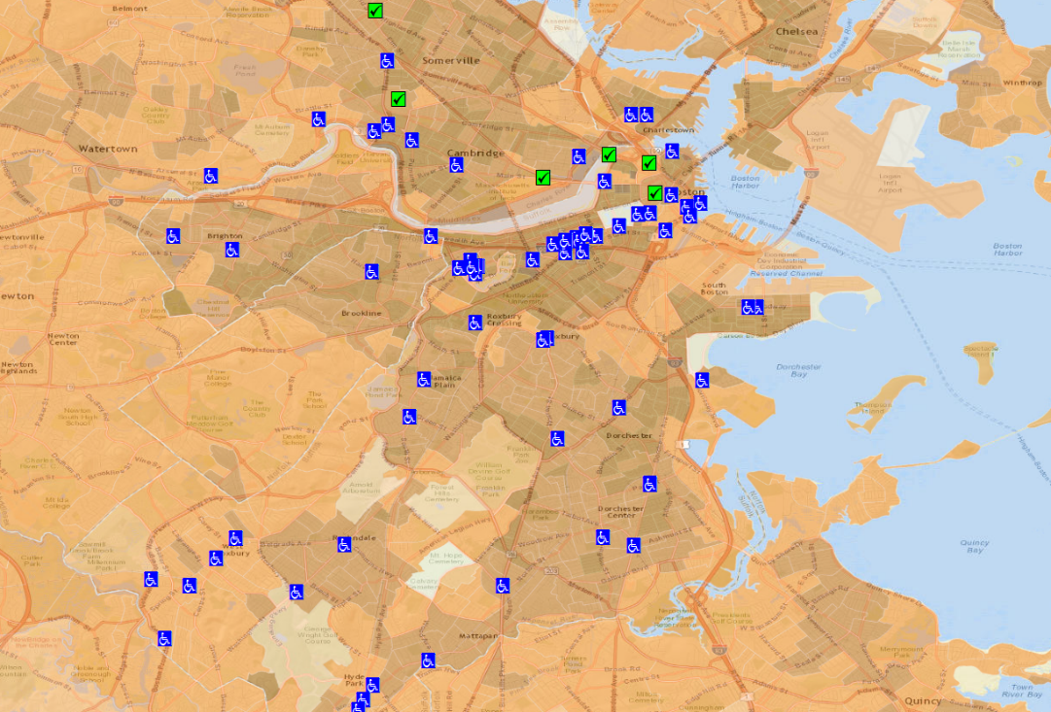

—

## Gender Neutral Restrooms

Finding restroom is a challenge for Transgender population in the US and worldwide. Currently, there are negligible resources available which can help persons of different gender identities to locate restrooms and plan their travel or outings. Also, there is increased risk of discrimination and harassment based on their sexuality. The project aims to map gender neutral restrooms and have a separate layer.

As a part of the project, data was collected from 77 locations across Boston from various sources (Fenway Health, NU LGBTQ Resource Center, Manual Survey).

## Lack of Restrooms near Transit Stations in Boston

Most MBTA stations do not have any public restrooms nearby. Many of the MBTA stations which do have restrooms, they are inside the station area, which requires a ticket to get in. Lack of public restrooms alleviates the problems of the homeless, who mostly take shelter in the stations.

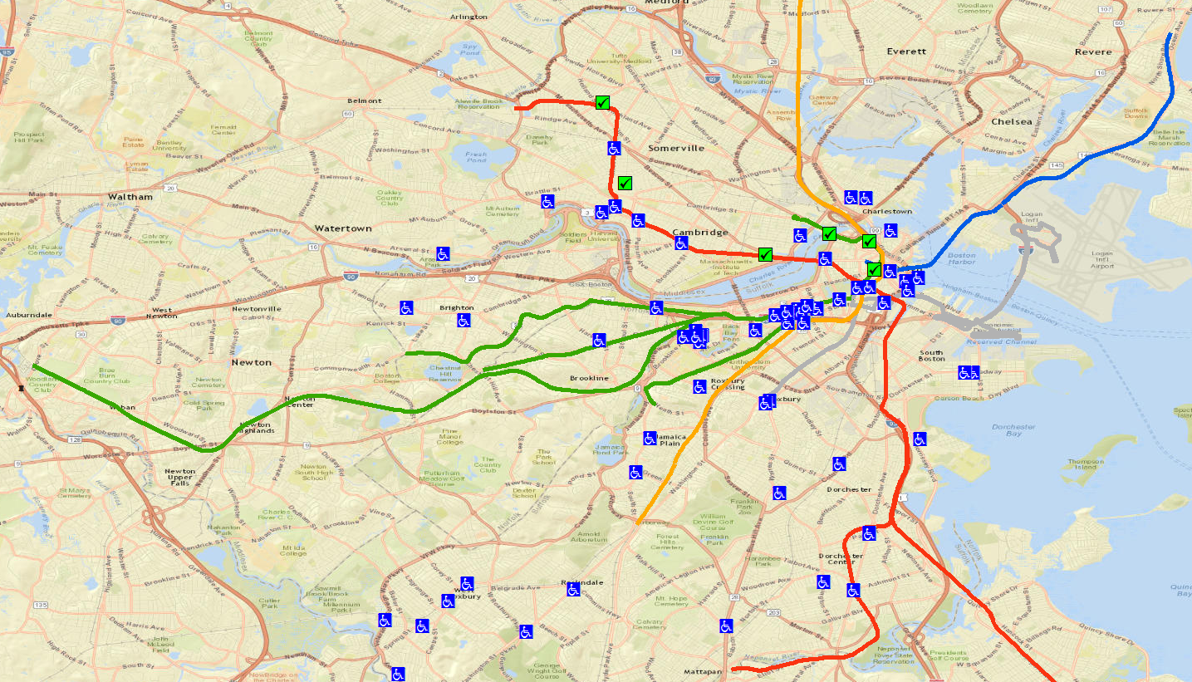

## Lack of Restrooms near Public Parks

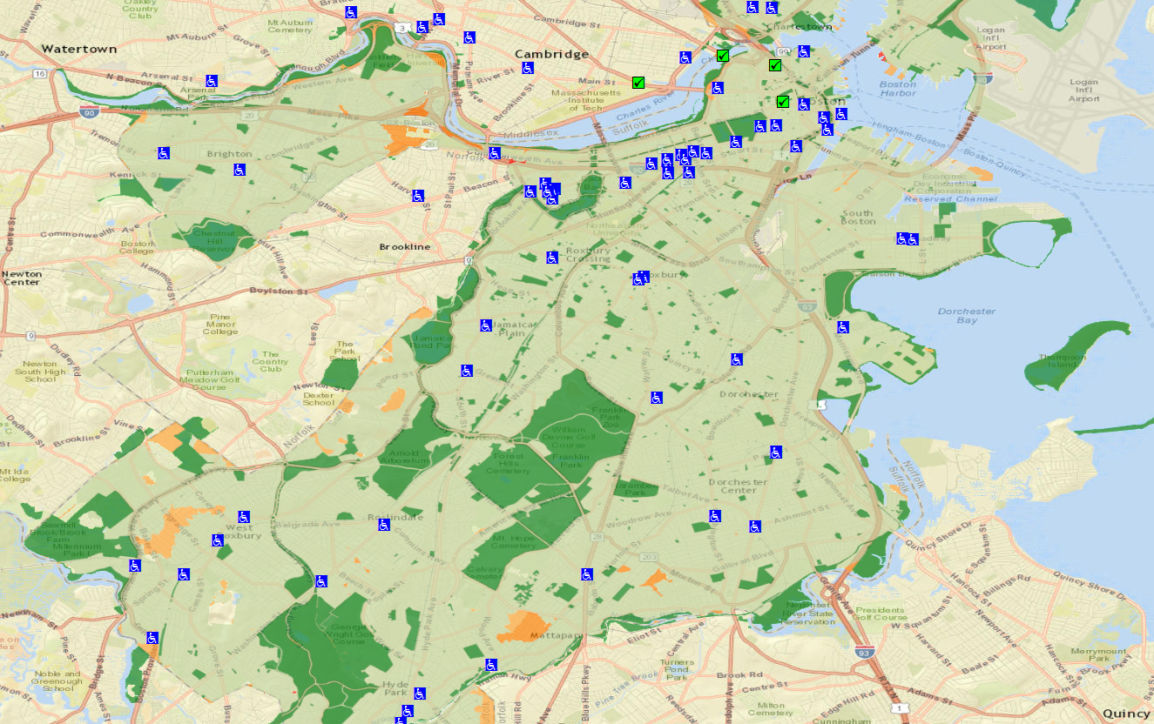Many public parks in Boston lack any public restrooms nearby. Surveys have repeatedly indicated that restroom availability and drinking water are the most important amenities people wish for in parks. Problem for the elderly, women and children.

—

## Restroom Availability vs. Population Density in US states

The availability of restrooms is very less in the central and southern states compared to eastern states. Major cities and high population density areas have very few or no public restrooms (USDOT). The only option in the highly populated areas being paid/patron-only locations like cafes and restaurants.

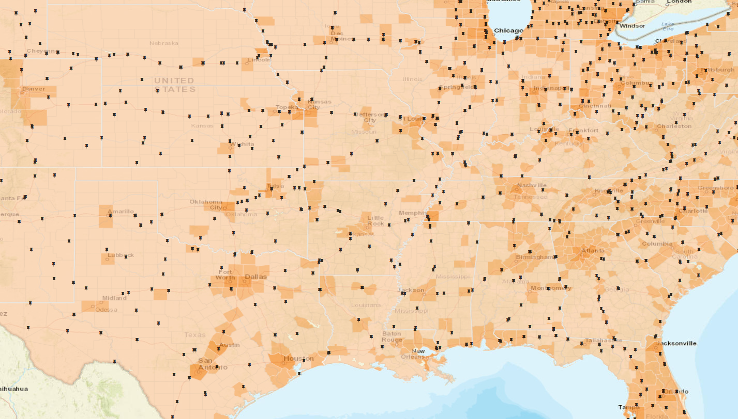

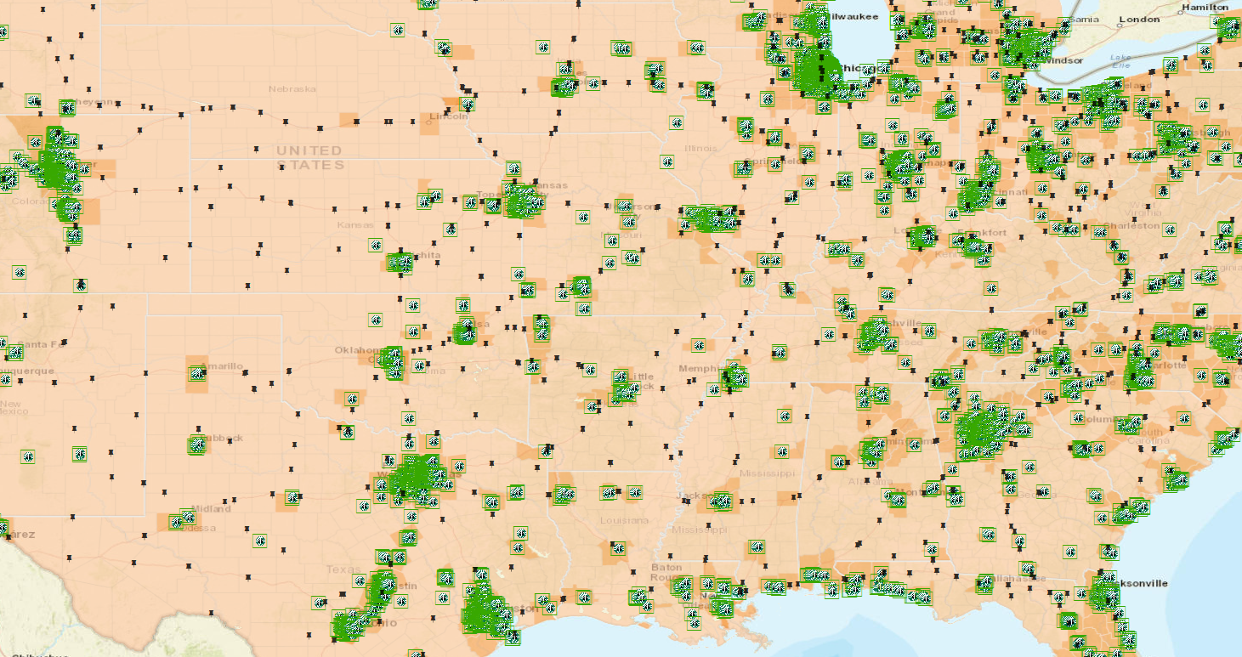

# Results

The project currently has more than 2500 public restrooms mapped, the details of which are as follows:

Public Restrooms **(4 feature classes: 2512 locations):**

* US DOT Rest Areas with restrooms: 2,225 Locations (US)
* Greater Boston Public Restrooms: 91 Locations
* Gender Neutral Restrooms (Boston): 77 Locations (5 Public + 72 University)
* Massachusetts Restrooms (Highways): 119 Locations

Patron only Restrooms **(3 Feature Classes: 24,845 locations):**

* Starbucks: 10,569 Locations (US)
* McDonalds: 14,268 Locations (US)
* Others: 8 Locations (Boston & Brookline)

Since this project’s primary objective is data availability and mapping, continuous efforts are needed to maintain and update the data. Additionally, as a secondary objective, more analytical layers can be added for obtaining newer insights to toilet use and policy effectiveness.

This project can be a very critical tool if extended to developing countries like rural India, Indonesia, China, Pakistan, Nigeria, Brazil etc. where accessibility to clean toilets is a major issue[5] and governments are trying to have the right resources and tools to work effectively.

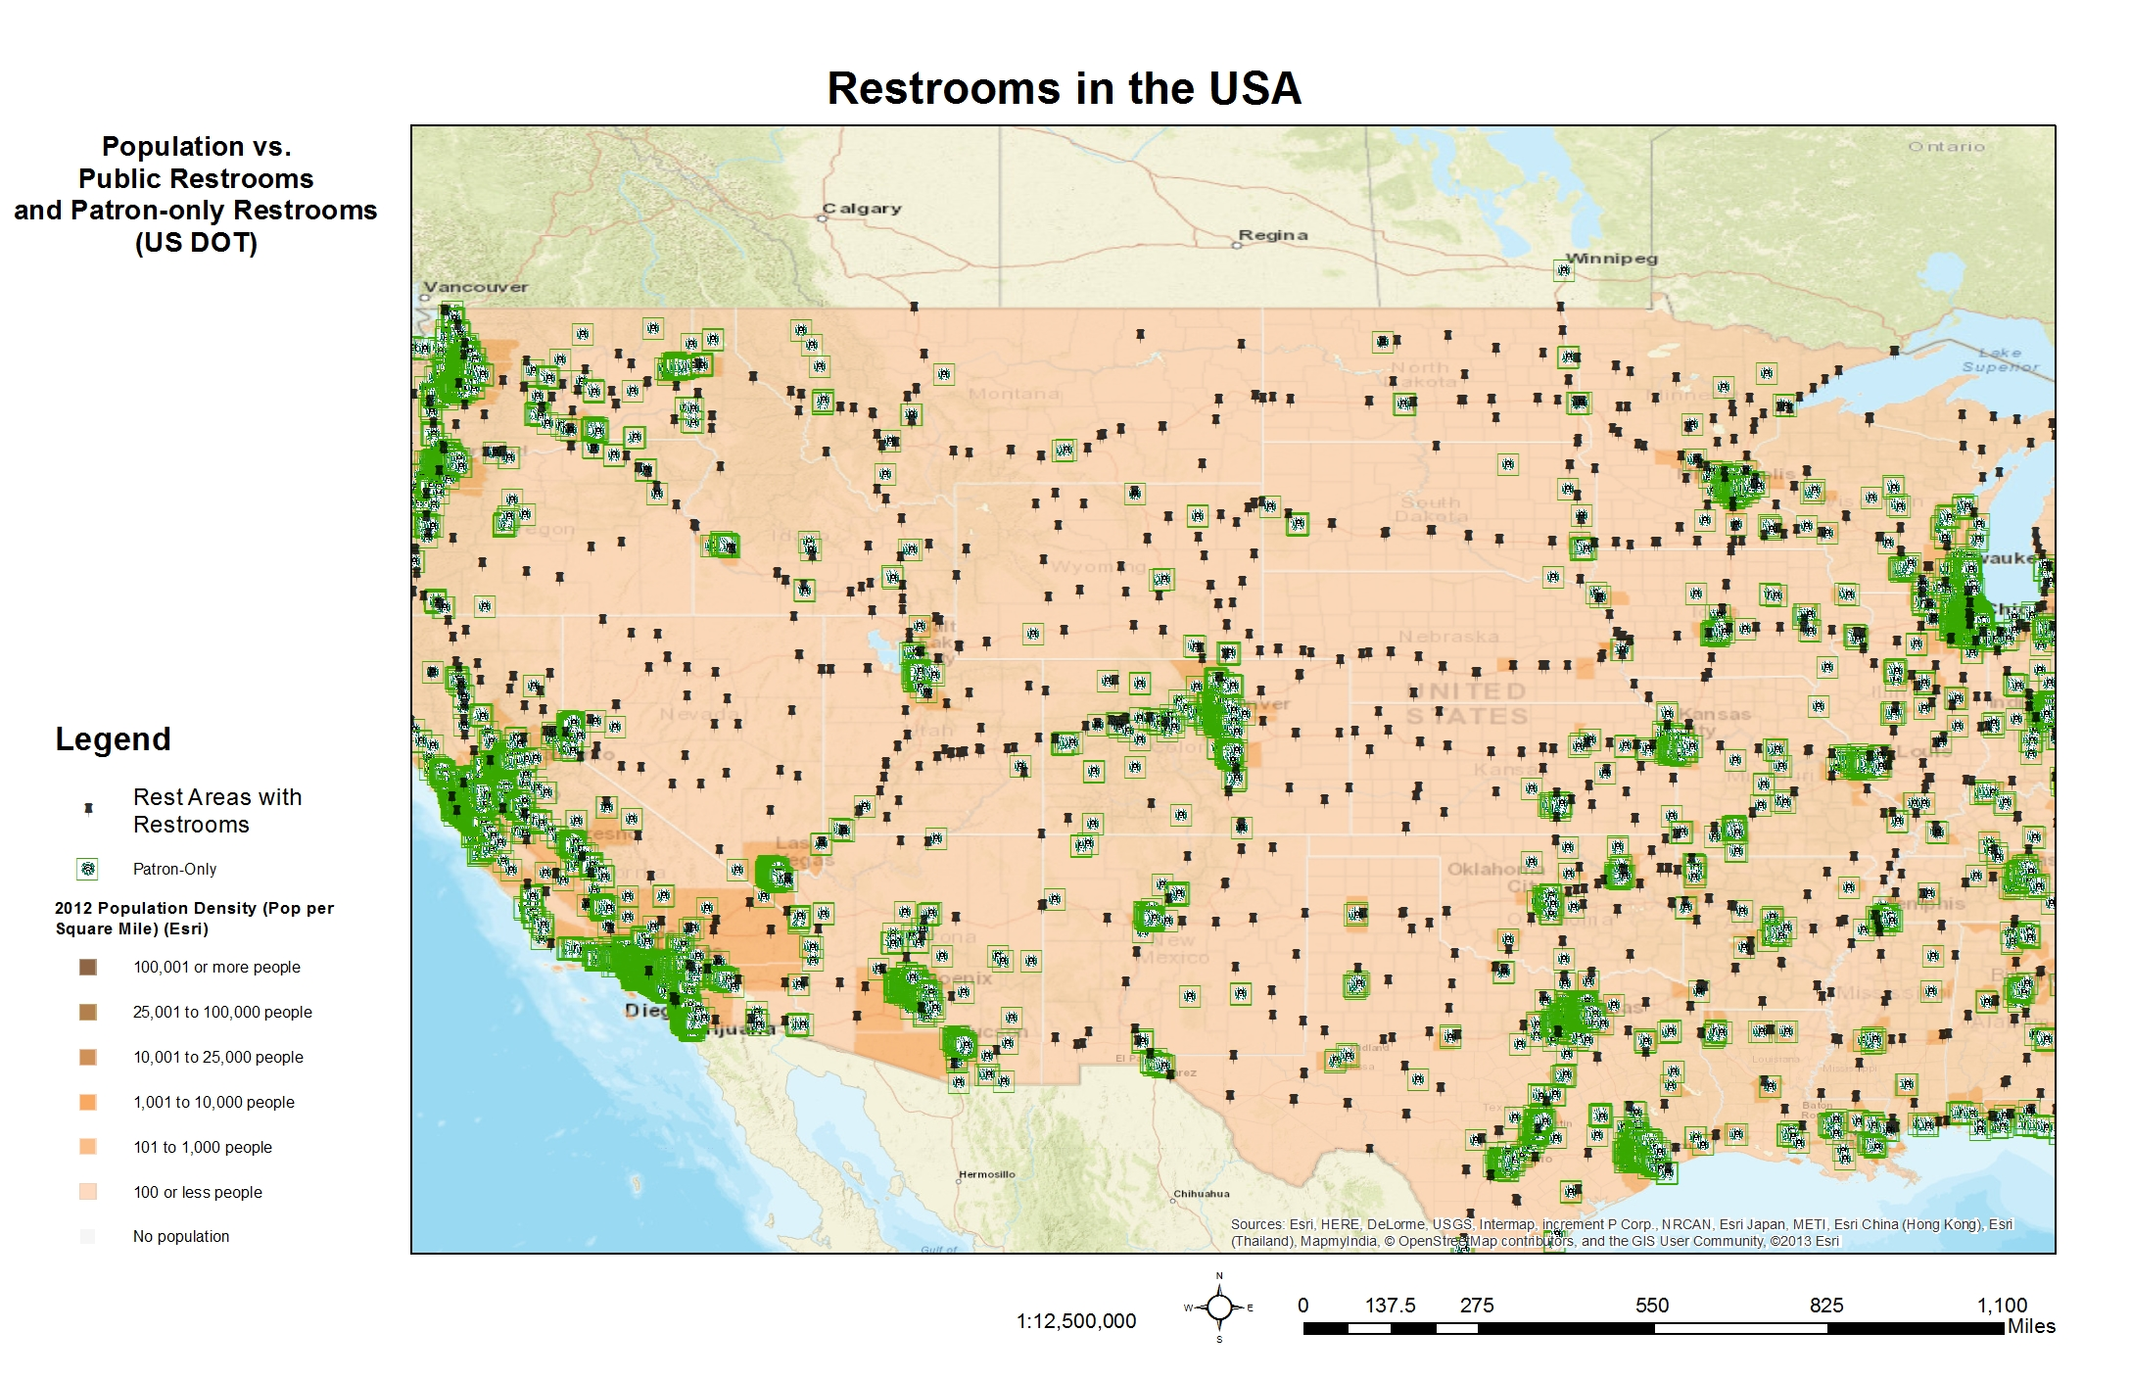

# Next steps

There are many enhancements or next steps this project can be undertaken as, some of the ideas are as follows:

* Add capability to include new restrooms using Collector Apps (e.g. ArcGIS collector).
* Integrate into Mobile Application platforms (iOS, Android, Windows) in the form of an app.
* GPS Enabled search for nearest restroom based on current location.
* Condition Reporting for existing Restrooms using crowd sourced mapping platform.
* Publishing data into the ArcGIS store for wider consumption.
* Integration of the web-service into an open-source online web mapping tool.
* Partnering with Health Centers and Civic Engagement authorities to help periodically feed data into the mapping system to keep the data up-to-date.

# Conclusion

It is evident that an application which maps data such as restrooms can be a helpful guide to a substantial section of the population who might be ‘restroom challenged’ and can give them confidence to travel without worrying about finding restrooms. Additionally, this can be a very important resource for the transgender community, who even to this day, face discrimination and taboo when it comes to choosing which restroom to go. This project can come handy to find and locate the nearest gender neutral restroom so that one can avoid using gender segregated restrooms in states which do not have adequate legal protection for the LGBTQ+ community.[7]

Policy wise, as illustrated in the maps, city councils, civic amenity authorities and NGOs can use the data and analytical capabilities of GIS to find out which areas/cities need improvement of services or areas which lack adequate public restroom availability per capita. It can also be used by private enterprises to install cheap coin operated restrooms or cabins on highways/routes which do-not have restrooms for miles.

**The project is not yet complete and is work in progress, with new data being added frequently and this document will be updated as and when major milestones are reached for the subsequent phases. Highlights of future plans can be seen on Page 3 (Step 9) and as indicated in the section ‘Next Steps’ above.**

# Appendix: Project Data

## Feature Class Fields/Classification:

The following is the data which is intended to be collected about restroom facilities:

Identification:

1. Name
2. Restroom Type (Public/Patron Only/Request/Affiliation)
3. Building Type (Restaurant/Train Station/Rest House/Hotel/Mobile/Beach/Café)

Location:

1. Longitude/Latitude
2. Address
3. City
4. State
5. Zip
6. Location/Area

Operations:

1. Seasons
2. Days
3. Hours
4. Location in Building

Accessibility:

1. Gender Specific (Yes/No)
2. Handicap Access (Yes/No)
3. Visible Signs (Yes/No)

Amenities:

1. Baby Changing Station (Yes/No)
2. Mirrors (Yes/No)
3. Shower (Yes/No)
4. Tissue Paper (Yes/No)
5. Hand Dryers (Yes/No)
6. Hot Water (Yes/No)
7. Sanitary Napkins (Yes/No)
8. Condoms (Yes/No)

Miscellaneous:

1. Fee Based Entry (Yes/No)
2. Access Fee
3. Condition Rating [1 – 5: Dirty – Clean]
4. Agency/Authority
5. Contact Number
6. Comment & Notes
7. Incorrect Location (Yes/No)
8. Facility Closed/Decommissioned (Yes/No)

## Data Sources

Below is a list of identified data sources and its details, this is used to connect with the agencies/individuals to request for relevant data needed for the project:

|  |  |  |  |  |
| --- | --- | --- | --- | --- |
| **Name** | **Address** | **Contact #** | **Email/Contact Methods** | **Existing Data** |
| [American Restroom Association](http://www.americanrestroom.org/pr/index.htm) | PO Box 65111  Baltimore, MD 21209 | 800-247-3864 - Information and general questions | [office@americanrestroom.org](mailto:office@americanrestroom.org) | [List](http://americanrestroom.org/survey/public_restroom_locate.pdf) |
| [Universal Hub](http://www.universalhub.com/restrooms) | Boston |  | [community@universalhub.com](mailto:community@universalhub.com) [adamg@universalhub.com](mailto:adamg@universalhub.com) | Excel |
| [MBTA](http://www.mbta.com/customer_support/contact/) | 10 Park Plaza, Suite 3910  Boston, MA 02116 | Toll Free: 1-800-392-6100  MBTA Customer Support Services (617)222-3200 | Customer Comment Form <http://www.mbta.com/customer_support/feedback/> | PDF Station Maps |
| [MassDOT](https://www.massdot.state.ma.us/portals/17/docs/statemap2012.pdf) | 10 Park Plaza, Suite 4160  Boston, MA 02116 | 857-DOT-INFO (857-368-4636) | <http://www.massdot.state.ma.us/ContactUs.aspx#Contact> MassDOT Public Records Request: [massdot.rao@state.ma.us](mailto:massdot.rao@state.ma.us) <http://www.massdot.state.ma.us/ContactUs/PublicRecordsRequests.aspx> | [List](http://www.massdot.state.ma.us/highway/TrafficTravelResources/TravelServicePlazasTouristInformationCenter.aspx) , [List in Map](https://www.massdot.state.ma.us/portals/17/docs/statemap2012.pdf) |
| [Brookline Community Aging Network](http://brooklinecan.org/restrooms.html) | 93 Winchester Street, Brookline, MA 02446 | 617-730-2777 | [info@brooklinecan.org](mailto:info@brooklinecan.org) | [List](http://brooklinecan.org/restroom_list.html), [PDF](http://brooklinecan.org/public_restrooms.pdf) |
| [Salem Bike Route Maps](http://www.salem.com/about) | Salem City Hall, 93 Washington Street, Salem, MA 01970 | 978-745-9595 | <http://www.salem.com/gis-and-maps> | [Map](http://www.salem.com/sites/salemma/files/uploads/routes.pdf) |

# References

## Topic Research

Pharmacy Times: <http://www.pharmacytimes.com/publications/issue/2005/2005-07/2005-07-9659> [1]

American Restroom Association: <http://americanrestroom.org/locate/index.htm> [2]

Overactive Bladder: <http://www.urologyhealth.org/urologic-conditions/overactive-bladder-(oab)> [3]

Society of Urologic Nurses and Associates: <https://www.suna.org/download/journal/article31106111.pdf>

Occupational Safety and Health Administration: <https://www.osha.gov/Publications/OSHA3795.pdf>

World Toilet Summit: <http://www.phlush.org/wp-content/uploads/2009/02/americanrestroomcalltoactionpaper.pdf>

Overactive Bladder in Middle Age Women (NAFC): <http://staging.nafc.org/uploads/pdf/articles/Annals%20of%20Urology%20-%20OAB%20in%20Middle%20Age%20Women%20-%20Final.pdf> [4]

World Toilet Day: Top 10 nations lacking toilets: <http://www.csmonitor.com/World/Global-Issues/2010/1119/World-Toilet-Day-Top-10-nations-lacking-toilets/Niger-12-million> [5]

National Association For Continence Survey: <http://www.prnewswire.com/news-releases/nationwide-survey-conducted-for-national-association-for-continence-shows-americans-divided--bathroom-seen-as-both-comforting-and-confining-82335547.html> [6]

Transgender policies across the country: <http://www.cnn.com/2016/04/27/health/transgender-laws-policies/> [7]

New York Times on Transgender Access to Restrooms: <http://www.nytimes.com/2016/05/13/us/politics/obama-administration-to-issue-decree-on-transgender-access-to-school-restrooms.html?_r=0> [7.1]

Restroom Bill in North Carolina/CNN: <http://www.cnn.com/2016/05/09/politics/north-carolina-hb2-justice-department-deadline/>

## Mapping Data

Universal Hub: <http://www.universalhub.com/restrooms>

Massachusetts Department of Transportation (MassDOT): <https://www.massdot.state.ma.us/planning/Main/MapsDataandReports/Data/GISData/RestAreas.aspx>

POI Factory: <http://www.poi-factory.com/>

[U.S. Department of the Interior](http://www.doi.gov/),  [U.S. Geological Survey](http://www.usgs.gov/): <http://viewer.nationalmap.gov/launch/>

Brookline Community Aging Network: <http://brooklinecan.org/restrooms.html>

US Rest Areas: <http://restareas.appspot.com/>

Mass GIS: <http://www.mass.gov/anf/research-and-tech/it-serv-and-support/application-serv/office-of-geographic-information-massgis/>